**Group by :**

It is used to arrange data into groups .we use aggregate functions like max,count,sum etc.

Customers table:

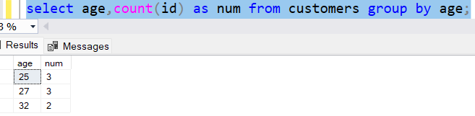

**Having:**

It is used instead of where with aggregate functions.

While the **group by** Clause groups rows that have the same values into summary rows. The having clause is used with the where clause in order to find rows with certain conditions. The having clause is always used after the group By clause.

Demo2: Demo4:

**Union :**

**Union all:**

**Tcl commands:**

works along with dml commands.

Customers table:

**Commit:**save the changes

**Rollback**:rollbacks the changes

**Savepoint:**creates points within the group of transactions in which to rollback

After first save point s1 the rows with age 22 gets deleted

After second save points2 rows with age 25 gets deleted

After third save points3 rows with age 24 gets deleted

After Rollbacked to save point 2 this is the final table

The transactions done at save point3 are undone as we rollbacked to s2.

**Data integrity:**

Data integrity is used to maintain accuracy and consistency ,trustworthiness of data in a table.

Data integrity is different from database integrity.

Database integrity concerns with how data is stored and internal validity.

Data integrity refers to the quality of your data and how it's stored by your company—but not necessarily how it's accessed by customers or other users.

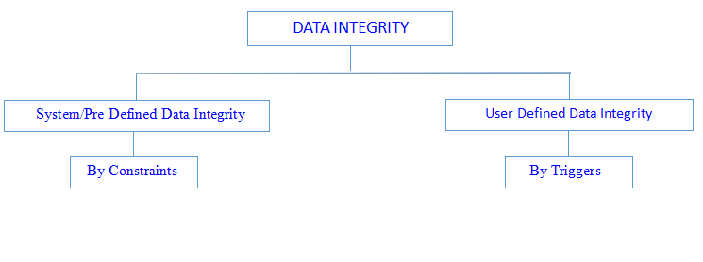

**Predefined /system data integrity:**

Using constraints

Constraints are used for enforcing, validating, or restricting data. Constraints are used to restrict data in a Table.

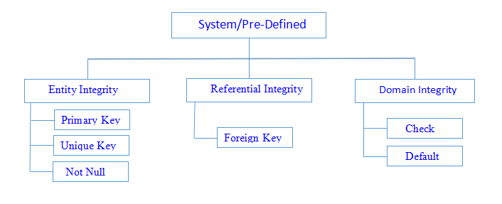

Entity integrity ensures each row in a table is a uniquely identifiable entity.

Referential integrity ensures the relationship between the Tables.

Domain integrity ensures the data values in a database follow defined rules for values, range, and format.